SCHOOLOFCOMPUTER SCIENCE AND ARTIFICIAL INTELLIGENCE |  |  |  |  | DEPARTMENTOFCOMPUTER SCIENCE ENGINEERING
ProgramName:M. Tech/MCA |  |  |  | AssignmentType: Lab |  |  | AcademicYear:2025-2026
CourseCoordinatorName |  |  |  | Venkataramana Veeramsetty
CourseCode |  |  | 24CS002PC215 | CourseTitle |  | AI Assisted Problem Solving Using Python
Year/Sem |  |  | I/I | Regulation |  | R24
DateandDay  of Assignment |  |  | Week1 - Tuesday | Time(s)
Duration |  |  | 2 Hours | Applicableto  Batches |  | M. Tech/MCA
AssignmentNumber:03.3(Presentassignmentnumber)/24(Totalnumberofassignments)
 | Q.No. | Question |  |  |  |  |  | ExpectedTime  to complete
 | 1 | Application for TGNPDCL  Objective:Build an application using Python program for TGNPDCL, to generate the bill based on energy consumption and type of customer with the help of AI tools.  Build a python application as per below instructions  - Read all the required data like PU,CU and Type of customer  - Calculate bill amount based on number of units consumed, type of customer and othercharges  - Finally print the values of EC(Energy Charges),FC(Fixed Charges),CC(Customer Char-ges),ED(Electricity Duty Charges),bill as per expected output  Requirements:  - VS Code with Github Copilot and/or Google Colab with Gemini  - Students should bring power bill from their home  Deliverables:  - Print energy bill for given inputs and verify with bill taken by students |  |  |  |  |  | Week2 - Wednesday

Objective:

To develop a Python program that calculates the electricity bill for TGNPDCL customers
based on energy consumption and customer type using AI tools such as GitHub Copilot.

Problem Statement:

The program reads previous and current meter readings (PU, CU) and the type of customer.
It calculates energy charges (EC), fixed charges (FC), customer charges (CC), electricity
duty (ED), and displays the total bill amount similar to a real TGNPDCL power bill.

Python Source Code

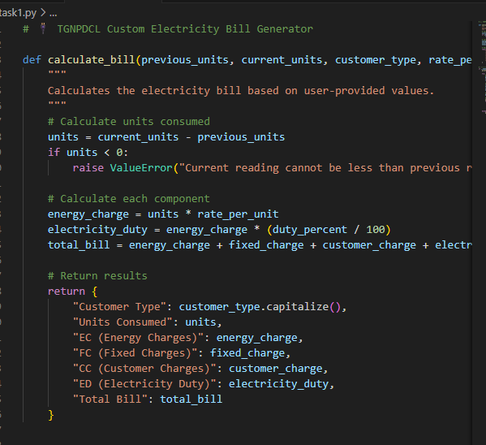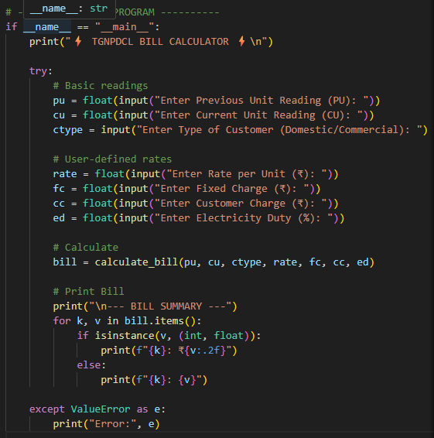

Output Screenshot

